Topic 3 – 2: Thinking on the unit circle
1. Answer each question by thinking about what each is telling you about the unit circle.

Say whether each statement is always true, sometimes true, or never true for x values in the interval $\frac{π}{2}<x<π$.
a. sin(x) > 0
b. sin(x) > cos(x)
c. tan(x) > 0
d. sec(x) > 0
e. csc(x) > 0

2. Answer each question by thinking about what sin(x) and cos(x) tell you about the unit circle. Don’t use a calculator!

- What values of x satisfy the equation: sin(x) = cos(x)
- Solve the equation: tan(x) = -1 . Of course, you could always write $x=\tan^{-1}\left(-1\right)$ but that doesn’t tell you much unless you know what $\tan^{-1}\left(-1\right)$ is. Think about what the equation is telling you about the unit circle and write an answer without inverse tangent.

- $sec⁡(90.01°)$ is [ choose one ]

a large positive number // a small positive number // a large negative number // a small negative number

Don’t be tempted by a calculator; think about what it’s telling you about the unit circle!
Explain in a sentence how you thought about this.

- Without a calculator, say which is larger: $sec⁡(10°)$ or $csc⁡(10°)$ . Why?

3. How can you write all the solutions?
a. Find all x values in the interval $0≤x<2π$ satisfying $\cos\left(x\right)=\frac{1}{2}$ . Write the answers without inverse cosine functions (since you know those angles!). Why are there actually 2 answers to this?

b. Give 2 or 3 answers for x which satisfy $\cos\left(x\right)=\frac{1}{2}$ but where $x>2π$. If there’s no restriction on x, how many solutions are there to this equation? Give a good way to write them all at once.

4. Extending what you can solve for.
a. What if $\cos\left(5x\right)=\frac{1}{2}$ ? Remember, you know how to think about $\cos\left(x\right)=\frac{1}{2}$. Use the blob strategy and think about what’s the angle? (give all solutions)

b. What if $\cos\left(x^{2}+1\right)=\frac{1}{2}$ ? (give all solutions)

5. Seeing symmetries.
Say you know that $\cos\left(47°\right)≈0.68$. Using that information, what would be the value(s) of $θ$, such that:

$cos(θ)=-0.68$ ( think about what this looks like on the unit circle )

Sketch a picture illustrating your answer. (There are 2 different answers (not including multiples of $360°$)).

6. An important identity.
Consider: $\cos\left(-x\right)=cos⁡(x)$
This is always true (for any x-value). Let’s look at two different ways of seeing why.

a. For an angle x where is the point at angle -x and angle x on the unit circle? (mark them!) Why are their cosines the same?

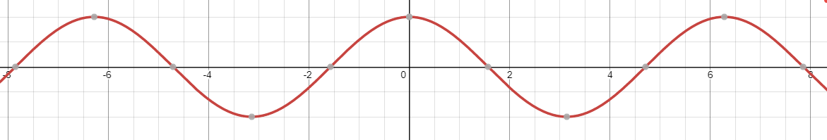
b. How can you see this same fact thinking in terms of transformations of the $y=\cos\left(x\right)$ graph? Why should the graph of $\cos\left(-x\right)$be equal to $cos⁡(x)$ ?

7). Is it the same identity for sine?
In the last problem you thought about $\cos\left(x\right)=cos⁡(-x)$ in two ways:
- comparing two points on the unit circle
- comparing two graphs

a). Do the same to explain why: $\sin\left(-x\right)=sin(x)$ is NOT true. (do it both ways: what does the equation say about two points on the unit circle? Why is that clearly false? What does it say about two graphs? Why is that clearly false?)
b). Can you think of how to adjust the equation so that it is always true?

Topic 3 – 2: Thinking on the unit circle – Solutions
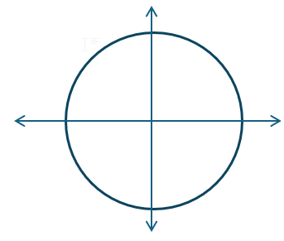
If $\frac{π}{2}<x<π$ we are in quadrant II.
a. sin(x) > 0 y-values are always positive in quadrant II.
b. sin(x) > cos(x) y-values are always larger than x-values
since x-values are negative in quadrant II.
c. tan(x) > 0 This is never true. $\frac{\sin\left(x\right)}{cos(x)}>0$ is only true when either x-values and y-values are both positive, or both negative.
This can’t happen in quadrant II.

d. sec(x) > 0 = $\frac{1}{cos⁡(x)}>0$ is never true because x-values are negative in quadrant II.

e. csc(x) > 0 = $\frac{1}{sin⁡(x)}>0$ is always true because y-values are positive in quadrant II.

2.
a. What values of x satisfy the equation: sin(x) = cos(x)
Angles where the y-coordinate on the unit circle is the same as the x-coordinate.
If we assume $0≤x<2π$, this happens at $x=\frac{π}{4}$ and $x=\frac{5π}{4}$.

b. Solve the equation tan(x) = -1. Say in 1 sentence how you think about it
Let’s re-write it as sine and cosine: $\frac{\sin\left(x\right)}{\cos\left(x\right)}=-1$ . By itself, this doesn’t (yet) immediately mean anything to me. Let’s clear the denominator, to give us: $\sin\left(x\right)=-cos⁡(x)$. This means something to me about the unit circle. It’s saying x is an angle where the sin(x) – the y coordinate – is equal to the opposite of cos(x) – the x-coordiante). So I want places where the y-coordinate and x-coordiante are the same magnitude, but opposite signs. This happens at $x=\frac{3π}{4}$ and $\frac{7π}{4}$.

c. How can we think intuitively about the vaue of $sec⁡(90.01°)$ ? First let’s write it in terms of cosine:
$sec\left(90.01°\right)=\frac{1}{cos\left(90.01°\right)}$ . That makes me want to know what $cos⁡(90.01°)$ is. Here’s a somewhat exaggerated picture, but you can see that $cos(90.01°)$ will be negative, and a very small number (since it’s a small x-value). So $\frac{1}{small negative}=$ $BIG negative$.
For example $\frac{1}{-\left(1/100000\right)}=-100000$. I’m not saying that’s the numeric answer, but I do know that whatever the answer is, it will be a large negative value.

d. Without a calculator, say which is larger: $sec⁡(10°)$ or $csc⁡(10°)$ . Why?
Again, the pictured angle is larger than $10°$ but we just need a picture that’s approximately right to help us think. You can see that the x-coordinate is larger than the y-coordinate. So if we’re comparing $\frac{1}{cos(10°)}$ and $\frac{1}{sin\left(10°\right)}$ a larger number in the denominator will mean the overall value is smaller (stop and re-read that sentence if you need to!).
At that point on the unit circle, sine has a smaller value than cosine. So a smaller denominator will mean a larger overall value, therefore csc(10) is larger.
3. How can you write all the solutions?
a. Find all x values in the interval $0≤x<2π$ satisfying $\cos\left(x\right)=\frac{1}{2}$ . Write the answers without inverse cosine functions (since you know those angles!). Why are there actually 2 answers to this?

You can read $\cos\left(x\right)=\frac{1}{2}$ in English as: “x is an angle to a place on the unit circle with an x-coordiante of $\frac{1}{2}$ ”. Looking at the unit circle you can see there are two places on the unit circle with an x-coordinate of $\frac{1}{2}$. It happens at $\frac{π}{3}$ and $-\frac{π}{3}$. But $x=-\frac{π}{3}$ is less than 0, and the problem said only angle greater than 0. That same angle is $\frac{π}{3}$ less than a full circle (which would be $2π$). In other words: $2π-\frac{π}{3}$, which is $\frac{5π}{3}$.
So, we can write those two locations as $x=\frac{π}{3}$ and $\frac{5π}{3}$.

b. Give 2 or 3 answers for x which satisfy $\cos\left(x\right)=\frac{1}{2}$ but where $x>2π$. If there’s no restriction on x, how many solutions are there to this equation? Give a good way to write them all at once.

Here’s a picture of one of the places on the circle that’s a solution. The smallest angle that corresponds to that point is $x=\frac{π}{3}$. In my picture, we could rotate 1 full circle and then go $\frac{π}{3}$ more to get to that same place. That would be an angle of $2π+\frac{π}{3}$. If you wanted to, you could also write it as $\frac{7π}{3}$ (one more $\frac{π}{3}$ than $\frac{6π}{3}$ which would be a full circle). I could go any number of full circles followed by $\frac{π}{3}$ and get the same place on the unit circle, which would still qualify as an answer (since the x-coodinate would still be $\frac{1}{2}$ ). Let’s write a few out:

1 full circle $+\frac{π}{3}= 2π+\frac{π}{3}$
2 full circles $+\frac{π}{3}= 4π+\frac{π}{3}$
3 full circles $+\frac{π}{3}= 6π+\frac{π}{3}$
4 full circles $+\frac{π}{3}= 8π+\frac{π}{3}$

Notice we could write: $\left(even \# of π^{'}s\right)+\frac{π}{3}$ and that would mean “any number of full circles $+\frac{π}{3}$ ”.

The typical was of writing this is to start with the $\frac{π}{3}$ and add any number of full circles.
$x=\frac{π}{3}+2π⋅k$ where k is an integer.

Imagine an integer, like 172. The we have a solution that’s $x=\frac{π}{3}+2π⋅172$ which would mean “172 full rotations and another $\frac{π}{3}$”, which lands on that exact same spot.

4. Extending what you can solve for.

a. What if $\cos\left(5x\right)=\frac{1}{2}$ ? Remember, you know how to think about $\cos\left(x\right)=\frac{1}{2}$. Use the blob strategy and think about what’s the angle?

Here’s how I see it: $\cos\left( \right)=\frac{1}{2}$ . I know that is the angle. I also know that angle points to a spot on the unit circle whose x-coordiante is $\frac{1}{2}$ . That means the angle is either $\frac{π}{3}$ or $-\frac{π}{3}$.

For $\cos\left(x\right)=\frac{1}{2}$ the angle is x, which immediately gives the answers $x=\frac{π}{3}, -\frac{π}{3}$.
For $\cos\left(5x\right)=\frac{1}{2}$ the angle is 5x, which means $5x=\frac{π}{3},-\frac{π}{3}$ (since 5x is the angle).
Dividing by 5 gives: $x=\frac{π}{15}$ or $-\frac{π}{15}$ .

The problem said to give all solutions, though. If the angle is $\left(any number of full circles+\frac{π}{3}\right)$, that means $5x=\frac{π}{3}+2πk$ where k is an integer. We can divide this by 5 to get: $x=\frac{π}{15}+\frac{2πk}{5}$ for integer k.

b. What if $\cos\left(x^{2}+1\right)=\frac{1}{2}$ ?
The equation is still saying: “there’s an angle whose x coordinate on the unit circle is $\frac{1}{2}$ ”, but now the angle is $x^{2}+1$. So I’m imagining: $x^{2}+1=\frac{π}{3}$ or $x^{2}+1=-\frac{π}{3}$ .

Let’s solve the first one: $x^{2}+1=\frac{π}{3}$ $x^{2}=\frac{π}{3}-1$ $x=\sqrt{\frac{π}{3}-1}$ or $-\sqrt{\frac{π}{3}-1}$
The second equation has no (real) solutions: $x^{2}+1=-\frac{π}{3}$ $x^{2}=-\frac{π}{3}-1$ , but a squared value can’t be negative, so no real solutions for x here.

Let’s do it in general. We know $\left(any number of full circles+\frac{π}{3}\right)$ work as an angle.
So $x^{2}+1=\frac{π}{3}+2πk$ for integer k. Solving: $x^{2}=\frac{π}{3}-1+2πk$ $x=±\sqrt{\frac{π}{3}-1+2πk}$

5. Seeing symmetries.
Say you know that $\cos\left(47°\right)≈0.68$.
Using that information, what would be the value(s) of $θ$, such that:
$cos(θ)=-0.68$

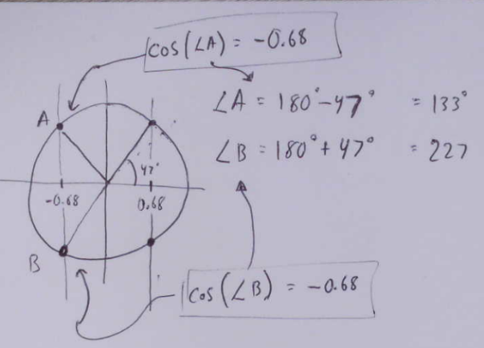
Sketch a picture illustrating your answer. There are actually 2 different answers (not including multiples of $360°$). Why?

Here’s my picture. I drew a vertical line where the x-coordinate is $0.68$. I know that angle is $47°$.

I want to know the angle where the x-coordinate is $-0.68$. So I drew a vertical line there.

I can see it’s the point that’s a horizontal reflection around the y-axis from the first one I drew. Since the first point rotated $47°$ counter-clockwise from 0, I know this new spot $∠A$ is rotating $47°$ clockwise from $180°$. There’s another symmetric value below the x-axis. I get this by rotating $47°$ beyond $180°$. So my two answers are $133°$ or $227°$ (not including adding multiples of $360°$).

6. An important identity
Consider: $\cos\left(-x\right)=cos⁡(x)$ This is always true (for any x-value).

Let’s look at why. A big idea in this problem is know that you can always think about any trig equation in these following two ways.

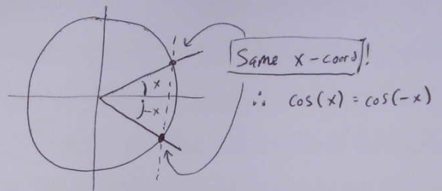
a. For an angle x where is the point at angle -x and angle x on the unit circle? (mark them!) Why are their cosines the same?

Here’s my picture. You can see the x-coordinate is the same because rotating clockwise or counter-clockwise by any rotation will give you symmetric points (reflected vertically over the x-axis).

Therefore, they’ll have the same x-coordinate.

b. How can you “see” this same fact thinking in terms of transformations of the $y=\cos\left(x\right)$ graph? Why should the graph of $\cos\left(-x\right)$be equal to $cos⁡(x)$ ?
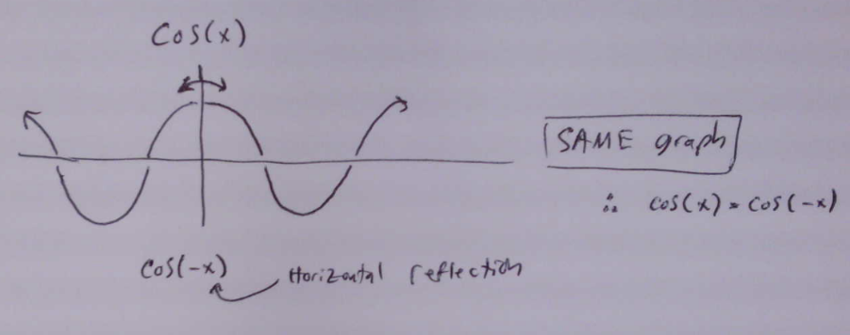
The big idea here is to see
$$\cos\left(x\right)=\cos\left(-x\right)$$
as
$\cos\left(x\right)=y=cos⁡(-x)$
Now you can compare:
$y=cos⁡(x)$ and $y=cos⁡(-x)$ and ask: “why are these graphs the same?”
$y=\cos\left(-x\right)$ is just a horizontal reflection of $y=cos⁡(x)$. My picture there shows the $y=cos⁡(x)$ graph and you can see that if you horizontally reflected it, the graph remains unchanged. That’s why they’re equal.

In the future, remember that no matter what trig equation you have you can think about it as describing something about coordinates for a point on the unit circle, OR as about transformations of a sine or cosine graph.

7). Is it the same identity for sine?
In the last problem you thought about $\cos\left(x\right)=cos⁡(-x)$ in two ways:
- comparing two points on the unit circle
- comparing two graphs

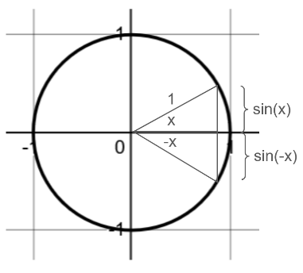
a). Do the same to explain why: $\sin\left(-x\right)=sin(x)$ is NOT true. (do it both ways: what does the equation say about two points on the unit circle? Why is that clearly false? What does it say about two graphs? Why is that clearly false?)
Using that same diagram of the point on the unit circle at an angle x and an angle -x we see this. But if we’re comparing the sine values, we’re comapring the y-values of those two points.
As you can see, the y-values are the same magnitude, but opposite signs: one is positive and one is negative. So they aren’t equal.

If we compare the graphs of $y=sin⁡(x)$ to $y=sin⁡(-x)$ they look like this: $y=sin⁡(x)$ is olid, and $y=sin⁡(-x)$ is the dashed horizontal reflection. Also, clearly not equal to each other.
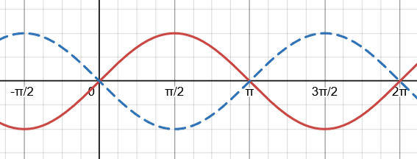

b). Can you think of how to adjust the equation so that it is always true?
Looking at the first digram above, it looks as if $\sin\left(x\right)$ has the same value as $sin⁡(-x)$ but one is positive and one is negative. To make them the same, let’s flip the sign of one of them: $\sin\left(x\right)=-sin⁡(-x)$ should work. Equivalently, you could write it $-\sin\left(x\right)=sin⁡(-x)$.
What happens if we think about this using reflections? Take the $y=sin⁡(x)$ graph and reflect it both horizontally and vertically. You’ll see that now it ends up the same as the original.

